SWTID-2026-3645Project Design Phase-II
Data Flow Diagram & User Stories

Date | 12 march 2026
Team ID | SWTID-2026-3645
Project Name | SpendWise
Maximum Marks | 4 Marks

Data Flow Diagrams:
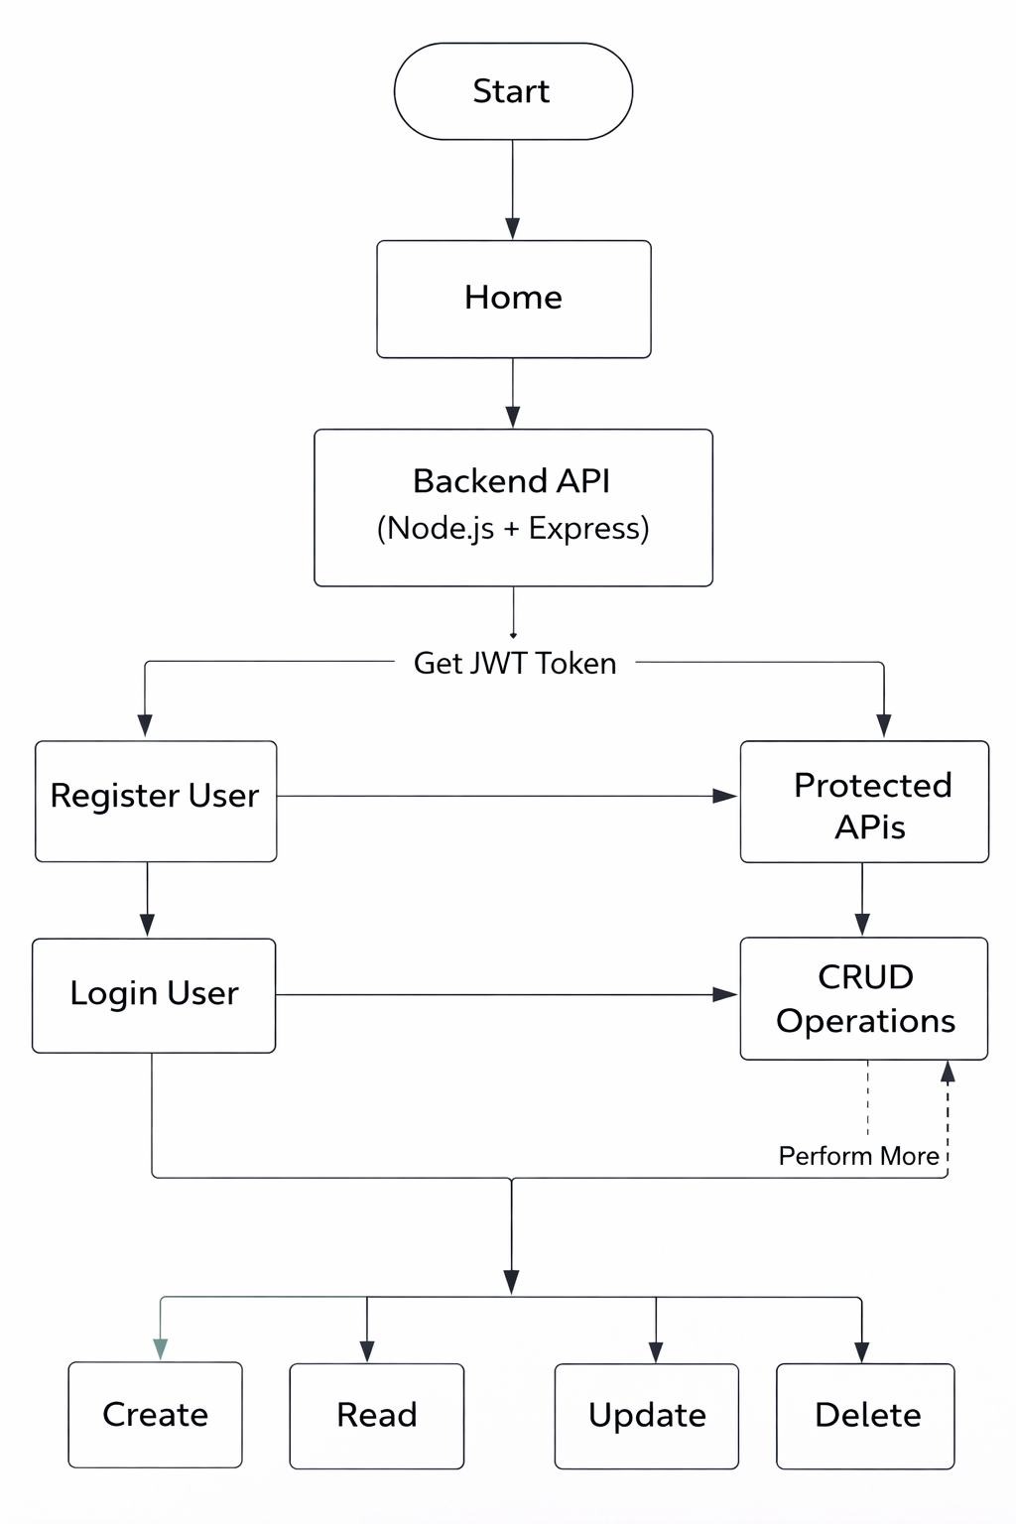

User Stories:
User Type | User Story Number | User Story / Task | Acceptance criteria | Priority | Release
User  (API User) | USN-1 | As a user, I can register using name, email, and password | User is able to create an account and receives a success response | High | Sprint-1
User  (API User) | USN-2 | As a user, I can login using email and password | User receives a valid JWT token after successful login | High | Sprint-1
User  (API User) | USN-3 | As a user, I can access protected APIs using JWT token | Requests without token are rejected; valid token allows access | High | Sprint-2
User  (API User) | USN-4 | As a user, I can create a new record/transaction | Record is saved in database and returned in response | High | Sprint-2
User  (API User) | USN-5 | As a user, I can view all my records/transactions | User receives only their own records from the system | High | Sprint-2
User  (API User) | USN-6 | As a user, I can update my record/transaction | Selected record is updated and new data is returned | Medium | Sprint-3
User  (API User) | USN-7 | As a user, I can delete my record/transaction | Selected record is removed and success message is returned | Medium | Sprint-3
User  (API User) | USN-8 | As a user, I cannot access other users’ data | System blocks access to data that does not belong to the user | High | Sprint-3

